|  |
| --- |
|  |
|  |

|  |  |  |  |  |  |
| --- | --- | --- | --- | --- | --- |
| REVISION HISTORY | | | | | |
| Ver. | Description of Change | Author | Date | Approved | |
| Name | Effective Date |
| 1.0 | Initial status | Hanna Hul | 22-NOV-2017 |  |  |

Contents

1. Data 3

2. Advanced Grouping tasks – Reports 3

2.1. Create Test AdHoc SQL - Daily Report (CUBE) 3

2.2. Create Test AdHoc SQL – ROLLUP by Time 3

# Data

The Main Task is to generate test data on Storage layers objects that was created on task 01.

Task Results:

The fact table was filled with the generated data. Functions dbms_random.value() and dbms_random.normal and their combinations were used for the generation. The parameters were connected with the size of dimensions to provide referential integrity.

SELECT * FROM fact _order;

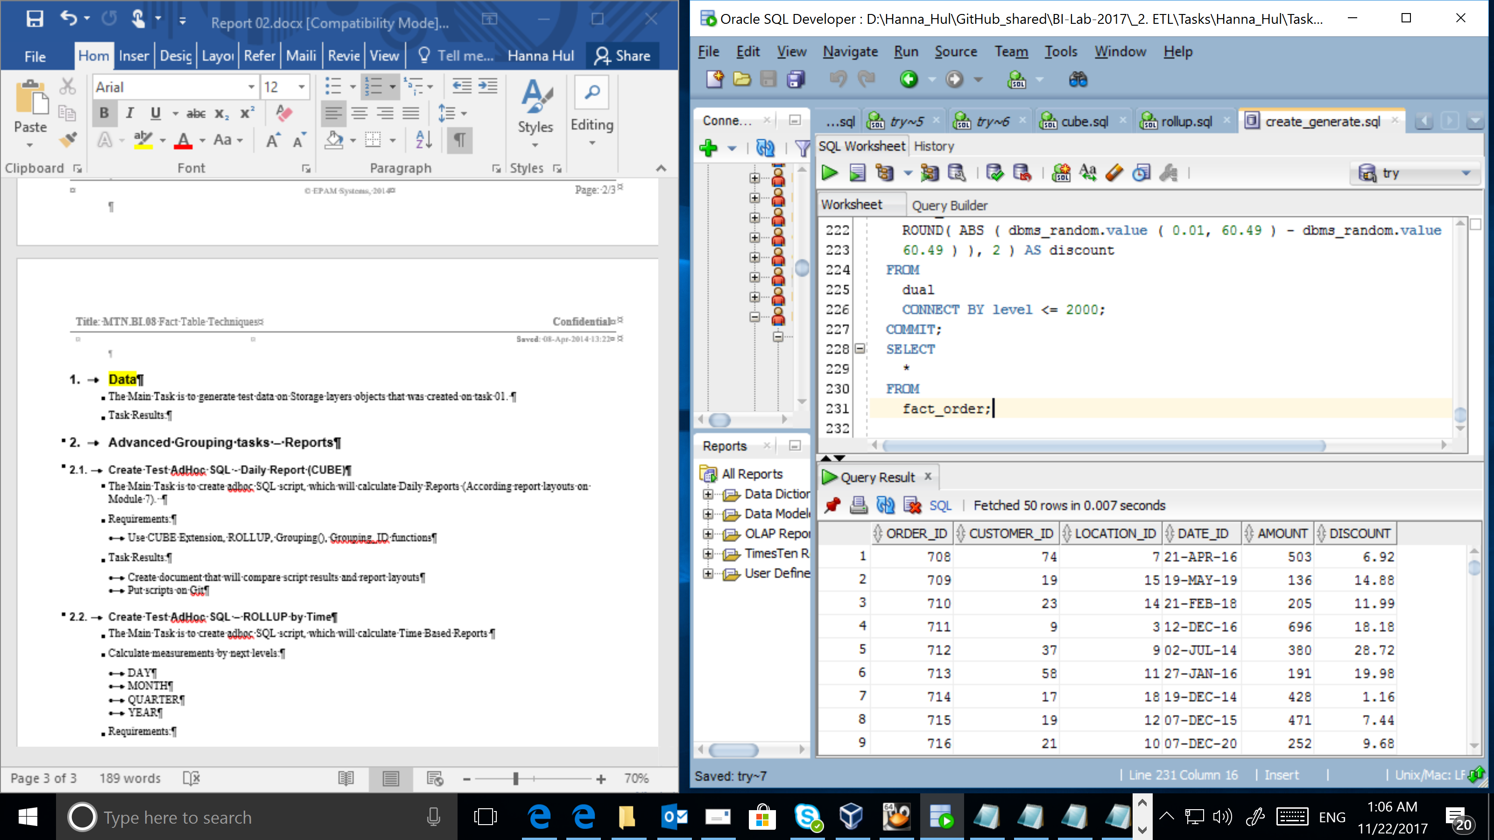

# Advanced Grouping tasks – Reports

## Create Test AdHoc SQL - Daily Report (CUBE)

select

-- dim_locations.city,

nvl(dim_date.year_id,'All years'),

nvl(dim_locations.country,'All countries'),

sum(amount*discount/100)

from

fact_order,

dim_locations,

dim_date

where fact_order.location_id = dim_locations.location_id AND

fact_order.date_id = dim_date.date_id

group by CUBE(dim_date.year_id,dim_locations.country)

order by grouping_id(dim_locations.country),2,1;

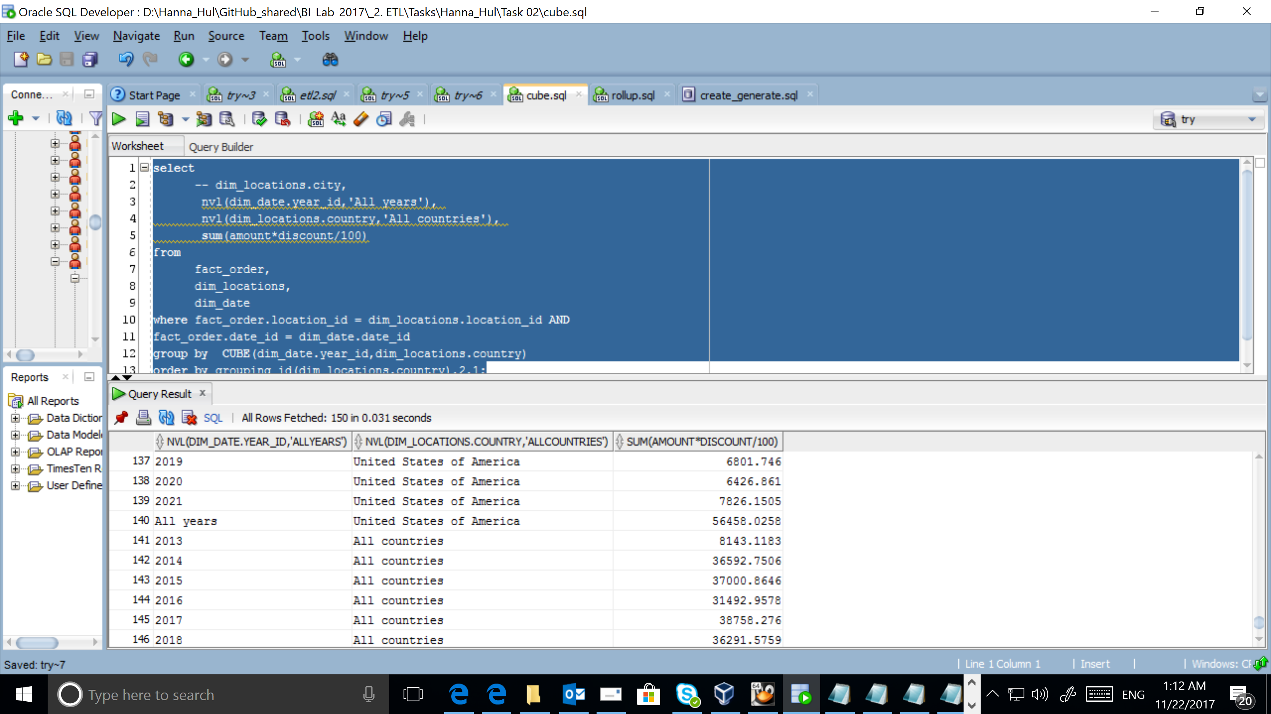

## Create Test AdHoc SQL – ROLLUP by Time

SELECT

dim_date.year_id,

dim_date.Quarter_ID,

NVL(dim_date.month_long,' '),

dim_date.Day_Num_of_Month,

SUM(amount*discount/100)

FROM

fact_order,

dim_date

WHERE --fact_order.location_id = dim_locations.location_id AND

fact_order.date_id = dim_date.date_id

AND dim_date.year_id >= 2017

AND dim_date.day_num_of_month <= 3

GROUP BY

dim_date.year_id,

ROLLUP(dim_date.Quarter_ID, dim_date.month_long, dim_date.Day_Num_of_Month);

--order by grouping_id(dim_locations.country),2,1; USE: Grouping_ID function

